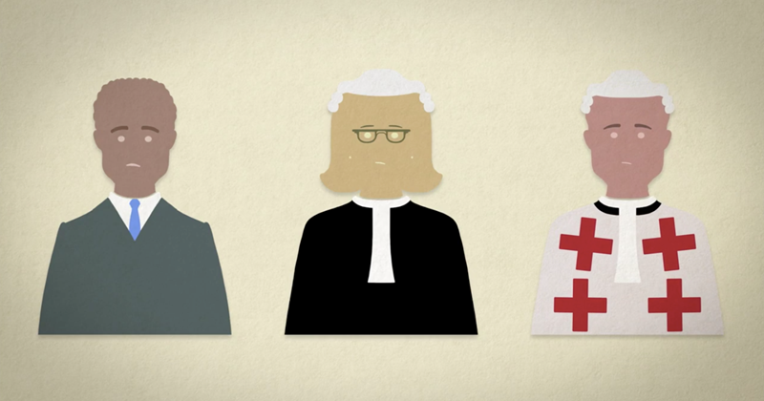

**National 5**

**Crime and the Law**

**Court:**

**Type of Crime:**

**Maximum Sentence:**

**Court:**

**Type of Crime:**

**Maximum Sentence:**

**Court:**

**Type of Crime:**

**Maximum Sentence:**

**SENTENCES**